**Experiment No. 3**

Name : Esha Pal ID.No.: VU4F2122047

Sub: BI Lab Div/Batch: A/C

**Aim:** Implement Data Preprocessing tools or languages like JAVA/ python/R.

**Data Preprocessing steps**

**Step 1:** Import the required libraries

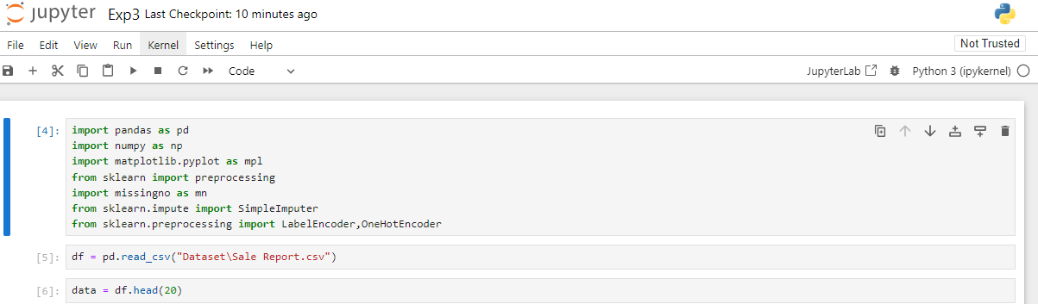

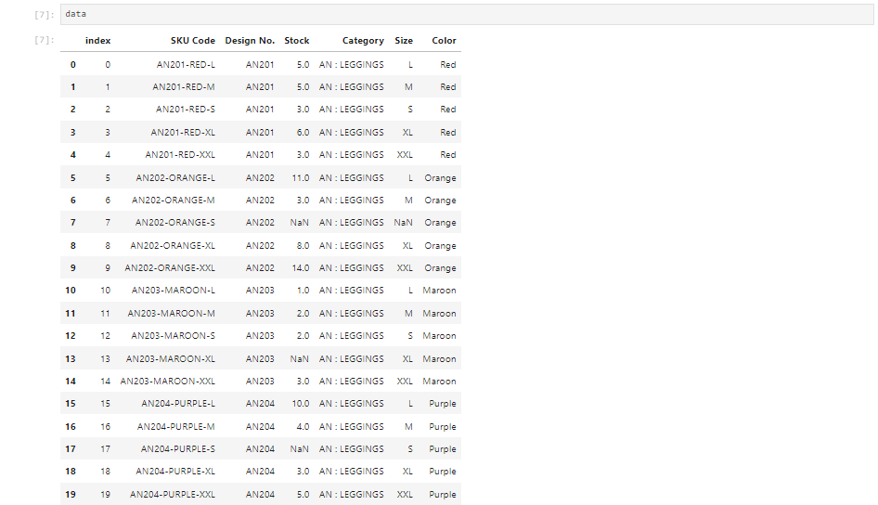

Step 2: Define the Preprocessing steps.

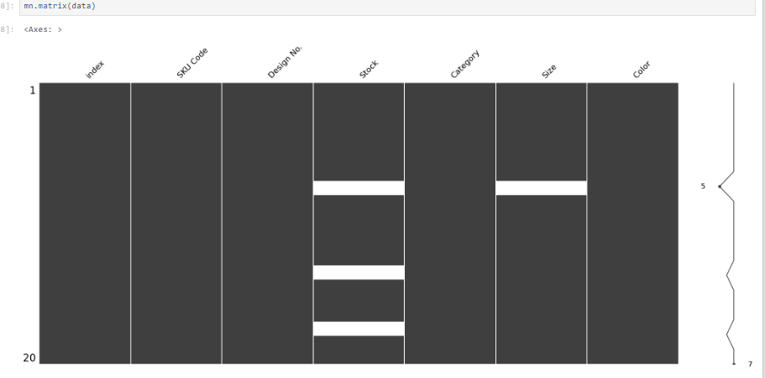

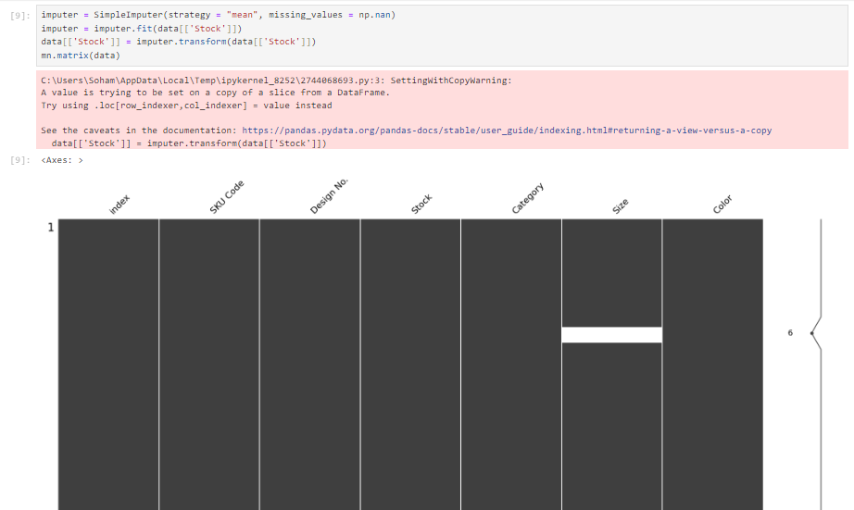

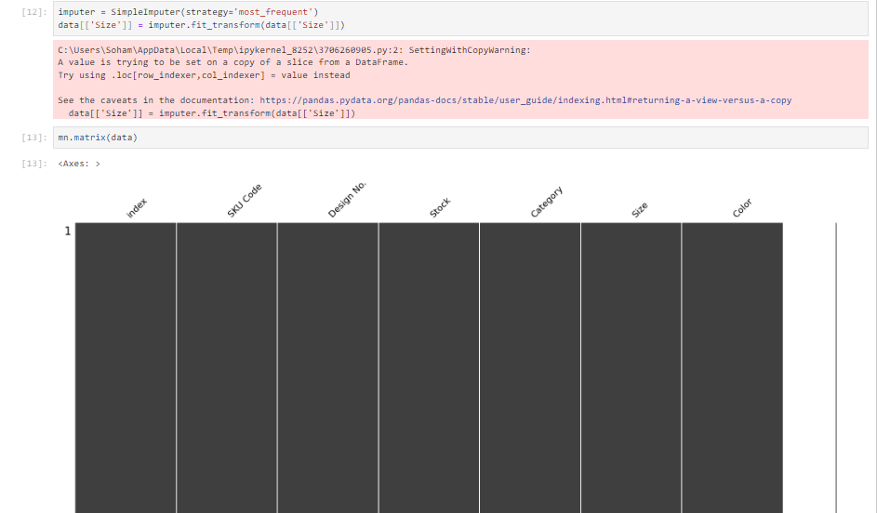

Step 3: Apply prepocessing to the dataset.

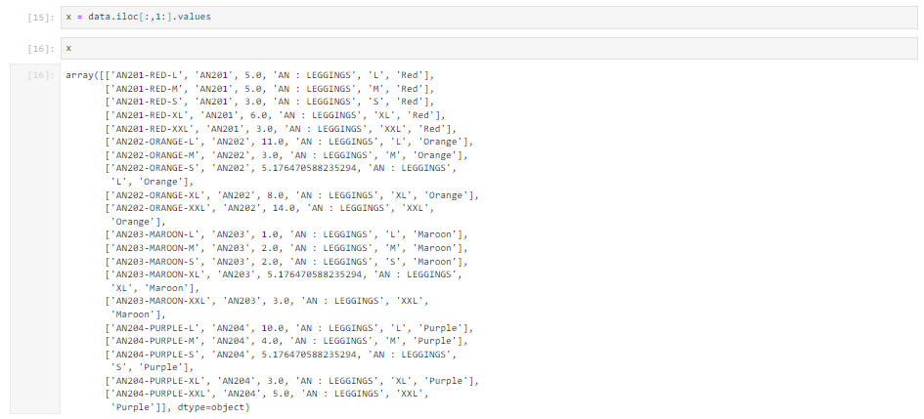

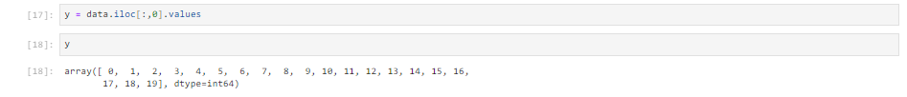

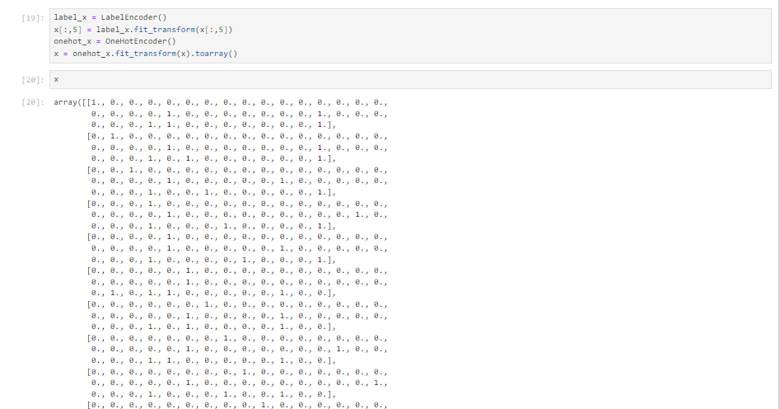

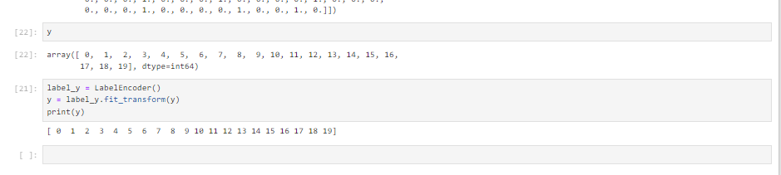

Now you have a preprocessed version of the dataset, X_preprocessed, which can be used for machine learning tasks.

**Conclusion:** Hence we implemented Data preprocessing using python.